Comma splice
A comma splice occurs when two or more complete sentences are joined only with a comma, which is not strong enough punctuation. This is an example of a comma splice:
Joseph Cornell was an innovative American artist known for his shadow boxes and collages, his art became more famous after his death in 1972.
Five Ways to Fix a Comma Splice
- Add a period and a capital letter
Add a period and a capital letter to separate the sentences.
  - Joseph Cornell was an innovative American artist known for his shadow boxes and collages. His art became more famous after his death in 1972.
- Add a comma and a coordinating conjunction
Add a comma and a coordinating conjunction. Coordinating conjunctions are easy to remember as F.A.N.B.O.Y.S.—for, and, nor, but, or, yet, so.
  - Joseph Cornell was an innovative American artist known for his shadow boxes and collages, but his art became more famous after his death in 1972.
- Add a semicolon
Add a semicolon if the sentences are closely related.
  - Joseph Cornell was an innovative American artist known for his shadow boxes and collages; his art became more famous after his death in 1972.

- Add a “transitional word”
Add a semicolon and a conjunctive adverb—also known as a “transitional word”. When using a transitional word, the comma should be placed immediately after the transition.
  - Joseph Cornell was an innovative American artist known for his shadow boxes and collages; however, his art became more famous after his death in 1972.
  - Common Transitional Words: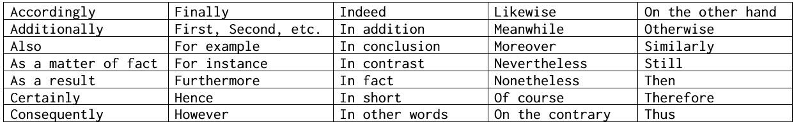
- Add a subordinating conjunction
Add a subordinating conjunction—also known as a “dependent word”—to the beginning or the middle of the sentence.
  - Even though Joseph Cornell was an innovative American artist known for his shadow boxes and collages, his artwork became more famous after his death in 1972.
    - In the example above, the comma stays when the conjunction "even though" is added to the beginning of the sentence.

  - Common Subordinating Conjunctions: